18. Suppose a hospital tested the age and body fat data for 18 randomly selected adults with the

following result.

*Question:*•

Calculate the mean, median and standard deviation of age and %fat using Pandas.

• Draw the boxplots for age and %fat.

• Draw a scatter plot and a q-q plot based on these two variables

Code:

import pandas as pd

import matplotlib.pyplot as plt

import seaborn as sns

import scipy.stats as stats

csv_path = r"C:\Users\jampa\Downloads\age_fat_percentage.csv"

df = pd.read_csv(csv_path)

print("Mean:\n", df.mean())

print("\nMedian:\n", df.median())

print("\nStandard Deviation:\n", df.std())

fig, axes = plt.subplots(2, 2, figsize=(12, 10))

# Boxplots

sns.boxplot(y=df["age"], ax=axes[0, 0])

axes[0, 0].set_title("Boxplot of Age")

sns.boxplot(y=df["fat_pct"], ax=axes[0, 1])

axes[0, 1].set_title("Boxplot of Body Fat Percentage")

# Scatter plot

sns.scatterplot(x=df["age"], y=df["fat_pct"], ax=axes[1, 0])

axes[1, 0].set_title("Scatter Plot of Age vs Body Fat Percentage")

axes[1, 0].set_xlabel("Age")

axes[1, 0].set_ylabel("Body Fat Percentage")

# Q-Q Plot

stats.probplot(df["fat_pct"], dist="norm", plot=axes[1, 1])

axes[1, 1].set_title("Q-Q Plot of Body Fat Percentage")

plt.tight_layout()

plt.show()

output:

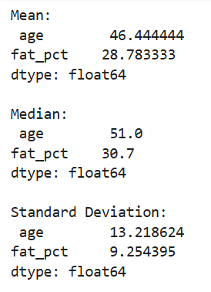

Dataset:

|  |  |  |
| --- | --- | --- |
| age | fat+A1:B20_pct | |
| 23 | 9.5 |  |
| 23 | 26.5 |  |
| 27 | 7.8 |  |
| 27 | 17.8 |  |
| 39 | 31.4 |  |
| 41 | 25.9 |  |
| 47 | 27.4 |  |
| 49 | 27.2 |  |
| 50 | 31.2 |  |
| 52 | 34.6 |  |
| 54 | 42.5 |  |
| 54 | 28.8 |  |
| 56 | 33.4 |  |
| 57 | 30.2 |  |
| 58 | 34.1 |  |
| 58 | 32.9 |  |
| 60 | 41.2 |  |
| 61 | 35.7 |  |
|  |  |  |